35. Sub-layers of the Data Link layer

The data link layer comprises of 2 more sub-layers –

1. LLC sublayer or DLC sublayer
2. MAC sublayer

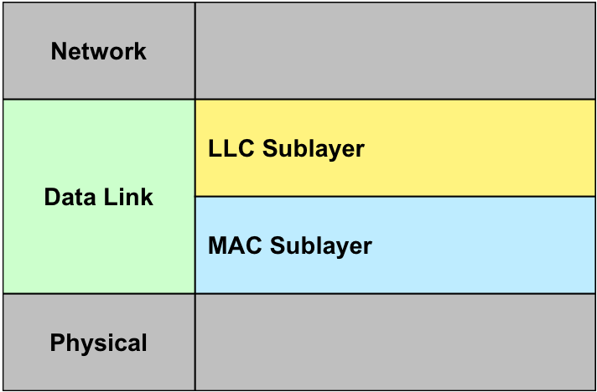

LLC sublayer or DLC sublayer –

* Logical Link Control and Data Link Control
* Handles communication between lower and upper layers of the data link layer.
* Flow Control – adds the source destination address to the data for delivering the packet to the destination.

MAC sublayer –

* It is the lower sublayer of the data link layer.
* The hardware connectivity like the Ethernet, RJ45, etc are connected via this layer.
* This connectivity is associated with the presence of the NIC cards.

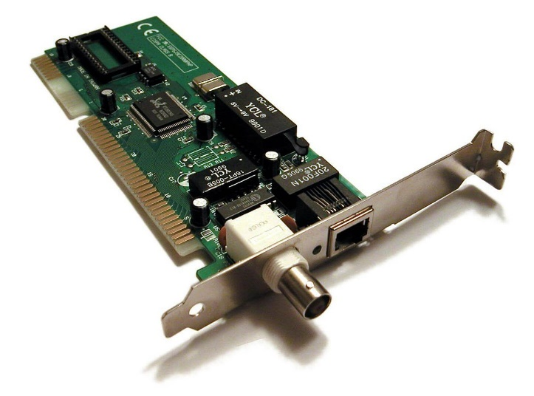NIC (Network Interface Card)

There are 2 primary responsibilities of the MAC layer –

* Data Encapsulation –

Here, the frame is formed when the MAC layer gathers the bits.

* Media Access Control –

MAC layer adds the MAC address to the frames. These are header and trailer, source MAC address and Destination MAC address.

The three primary functions of MAC Sublayer are –

1. Framing –

To collect the relevant data and inserting into frame for better recognition and understandability.

1. Physical Addressing or MAC Addressing –

To add source and destination MAC addresses to the data packets converted into a frame.

1. Error Control –

Since the sender cannot handle the errors, the data link layer’s MAC layer locates and resolves the errors within the network communication.